**借助<https://deepwiki.com/namkoong-lab/dro/4.2-neural-network-models>总结的内容理解 <https://github.com/namkoong-lab/dro>的内容**

**按照readme中教程顺利安装了dro包，探索了以下例子入门。**

**f-Divergence DRO**

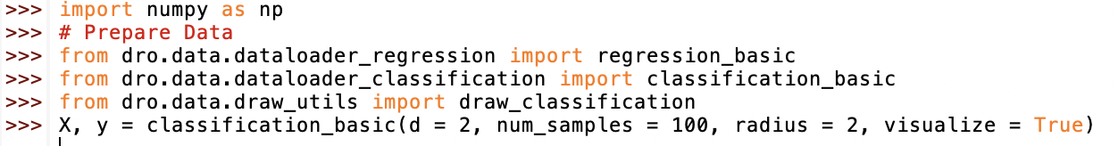

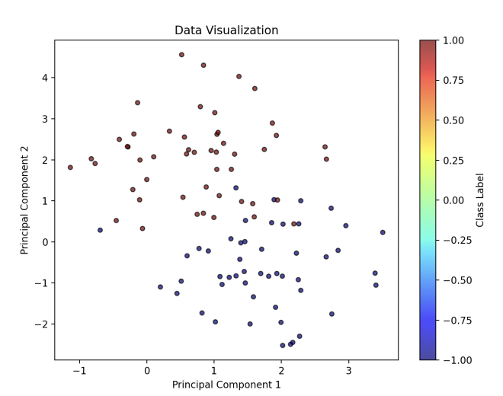

**Standard f-Divergence DRO**

* chi2 distance

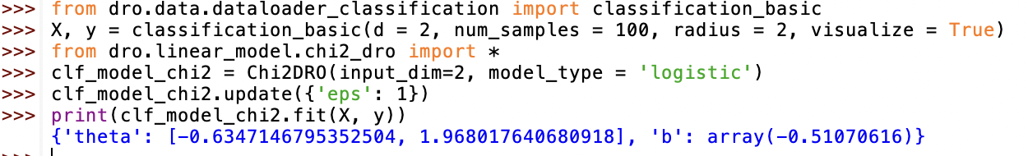

代码注释+结果分析<https://chat.deepseek.com/a/chat/s/dd6a5f07-ceef-47bb-90a0-6c8e072849ab>

worst case distribution



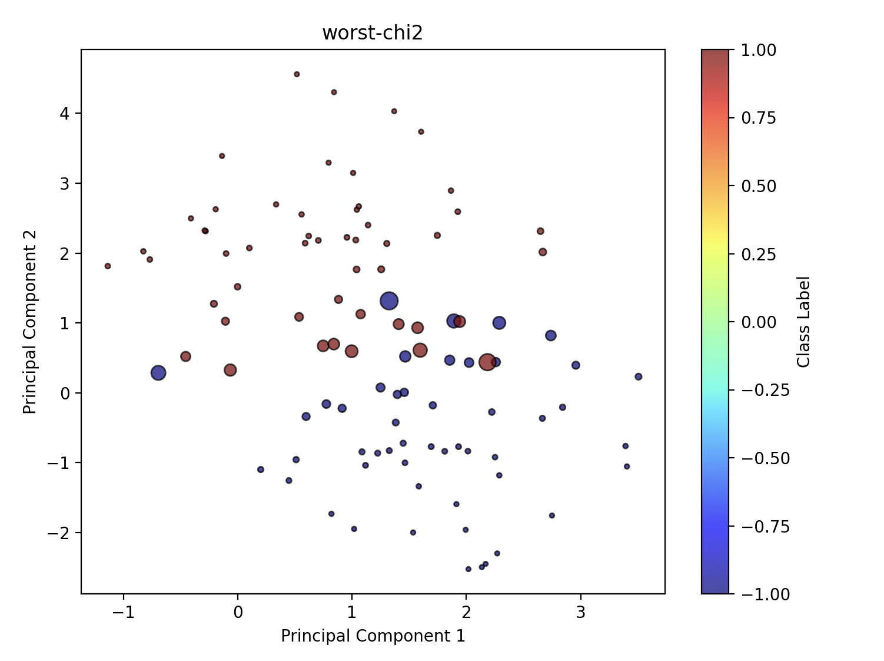

结果分析

<https://chat.deepseek.com/a/chat/s/6dc43769-6c5a-4839-930c-55d15ed25a60>

* cvar distance



worst case distribution



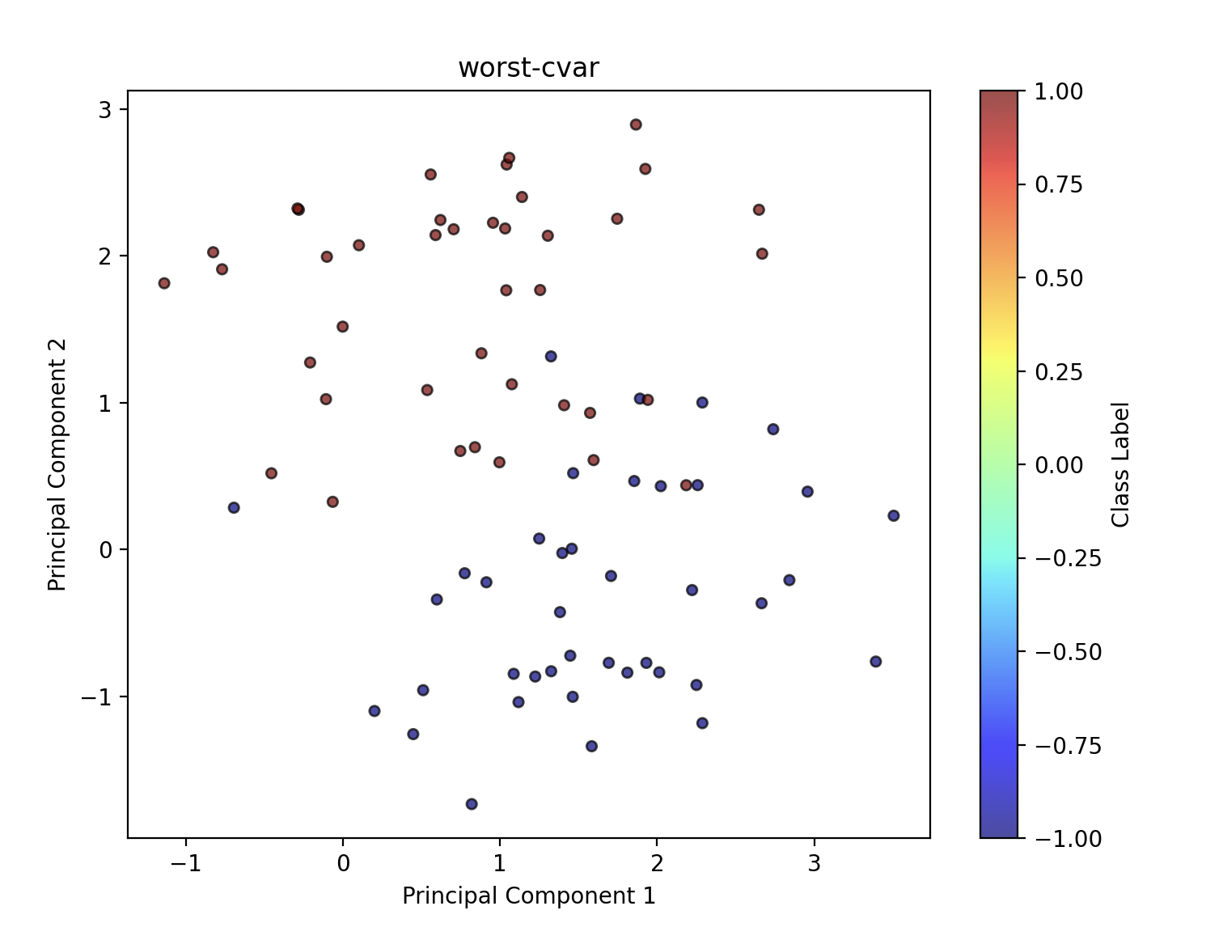

* tv distance



worst case distribution



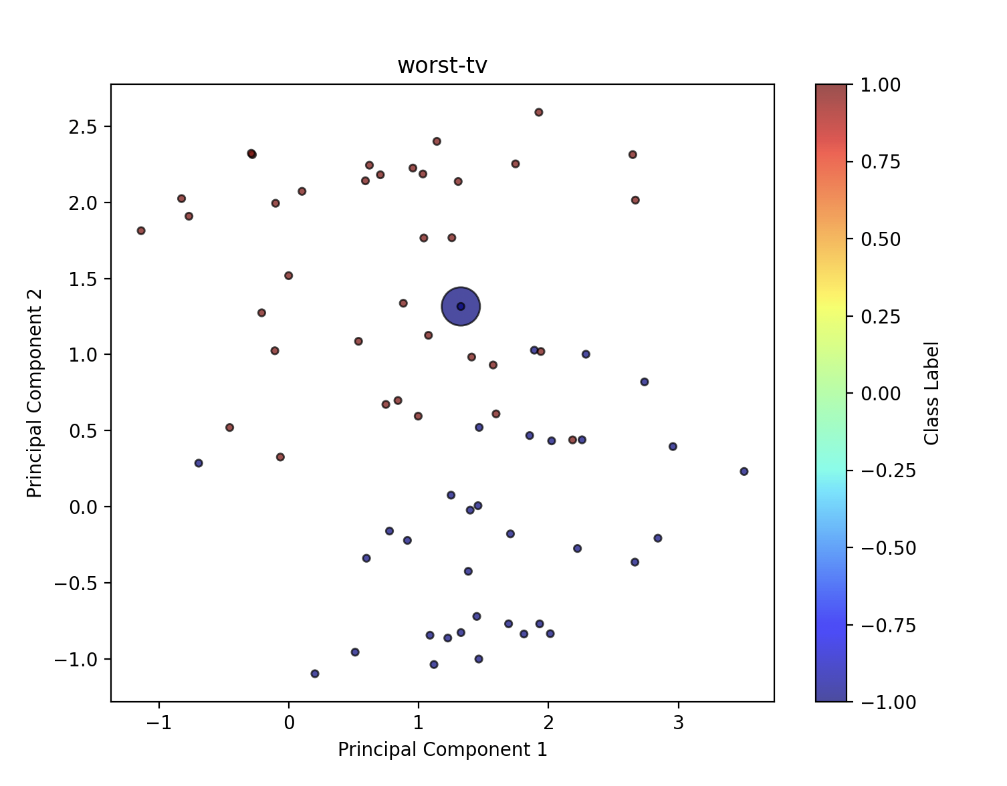

* kl distance



worst case distribution



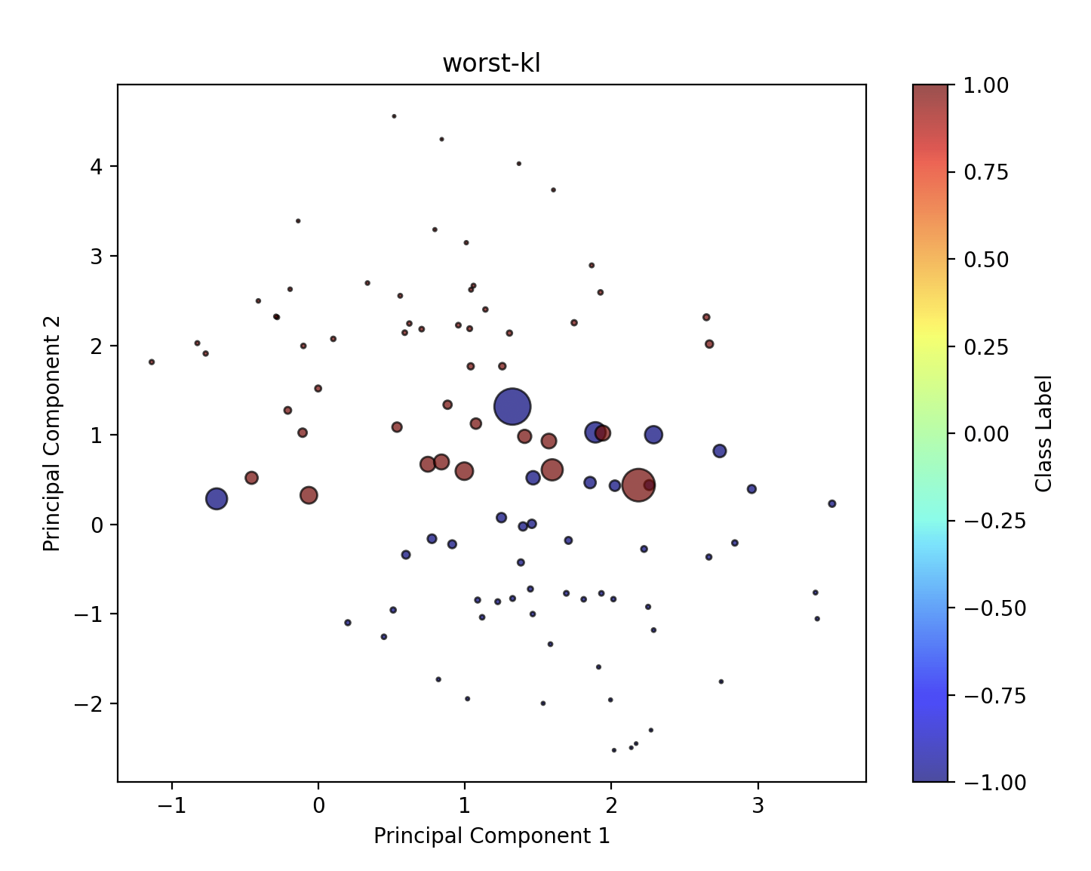

**data driven evaluation**

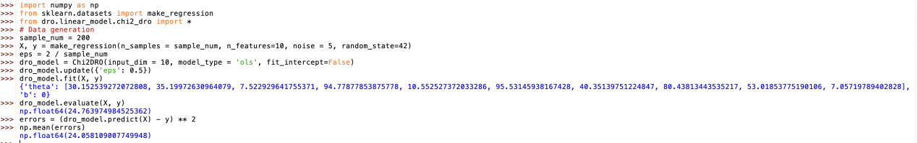

代码注释+结果分析

<https://chat.deepseek.com/a/chat/s/8582f1f4-32e5-4df2-8ad0-dc7712871507>

**Partial Distribution Shift**

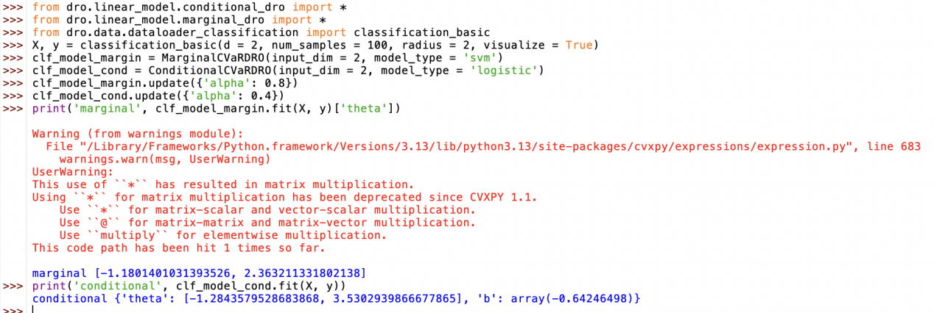

代码注释+结果分析

<https://chat.deepseek.com/a/chat/s/2e712e00-cf11-4f41-b4e9-c588a6868782>

**Wasserstein DRO**

**分类任务**

* 加载数据

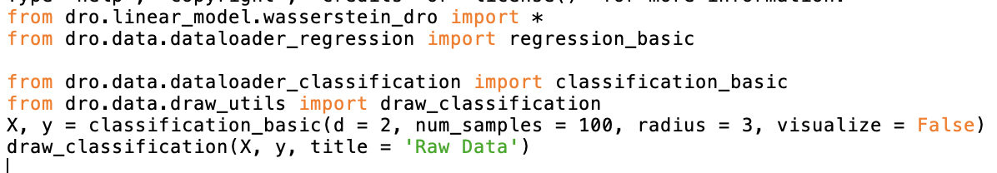

<https://chat.deepseek.com/a/chat/s/79431c35-51bb-4c66-bf63-13ac4cd38325>

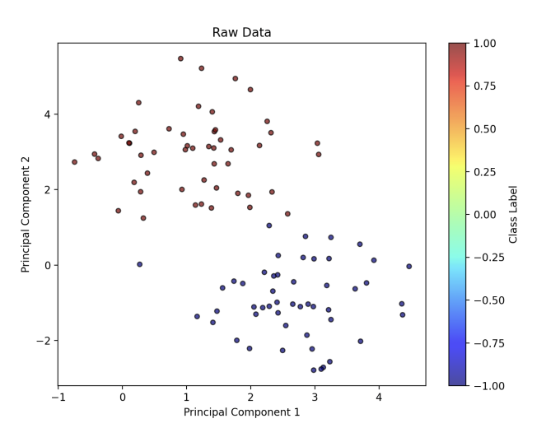

* 模型拟合

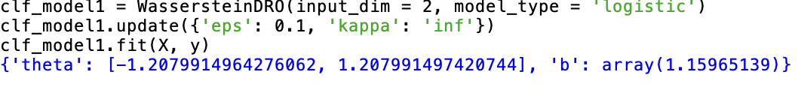

<https://chat.deepseek.com/a/chat/s/55ef6465-5d26-45b8-8984-2777801f8f70>

* 最坏情况分布和可视化

<https://chat.deepseek.com/a/chat/s/8c5f49dd-e4a3-431e-ae9d-e5052f72eccf>

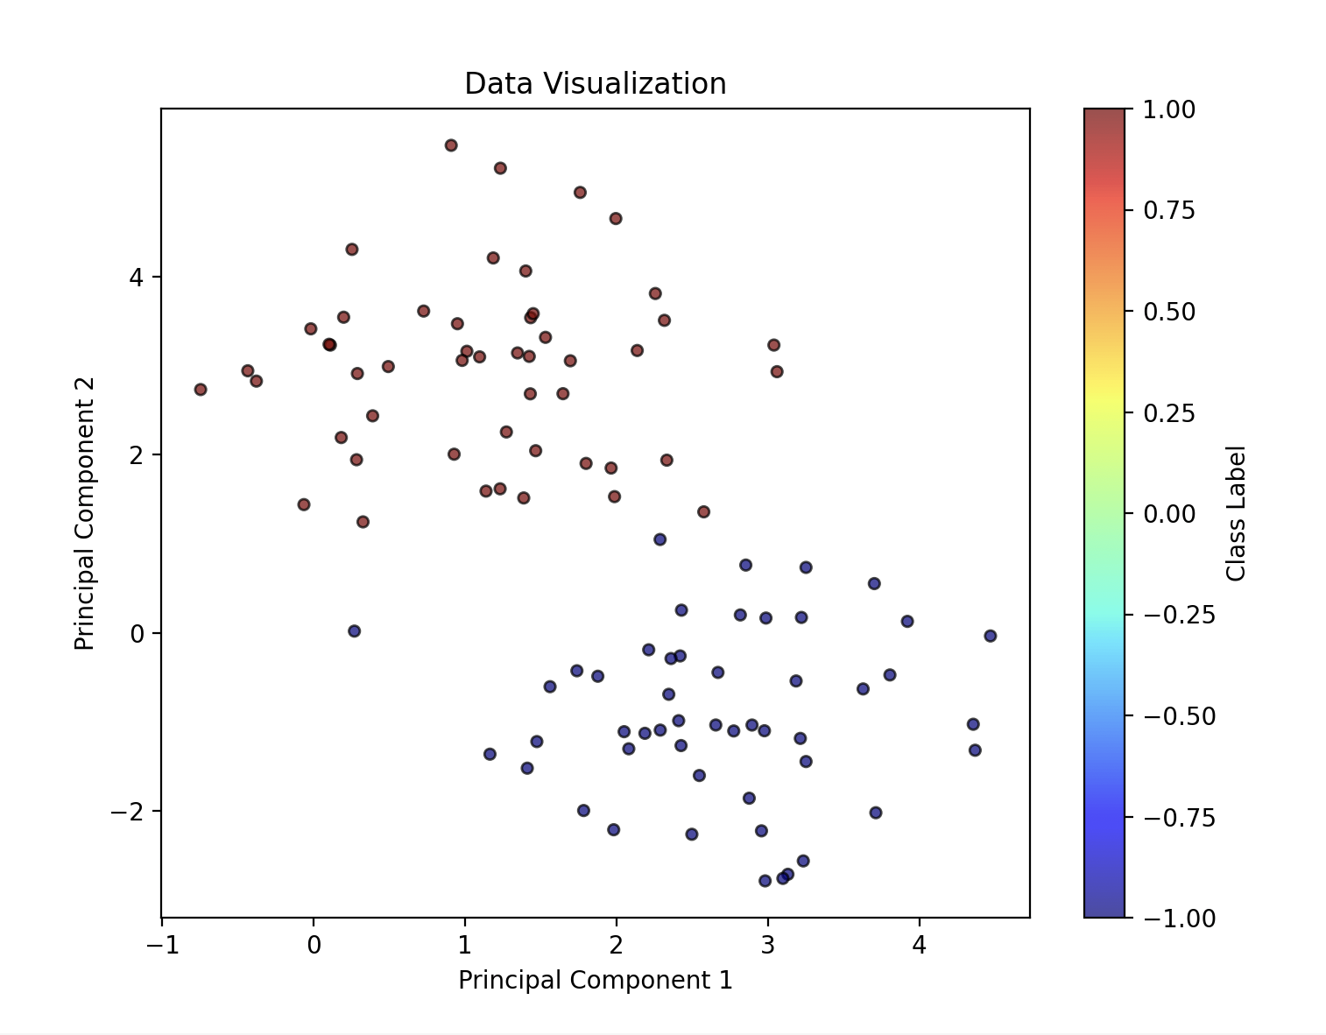

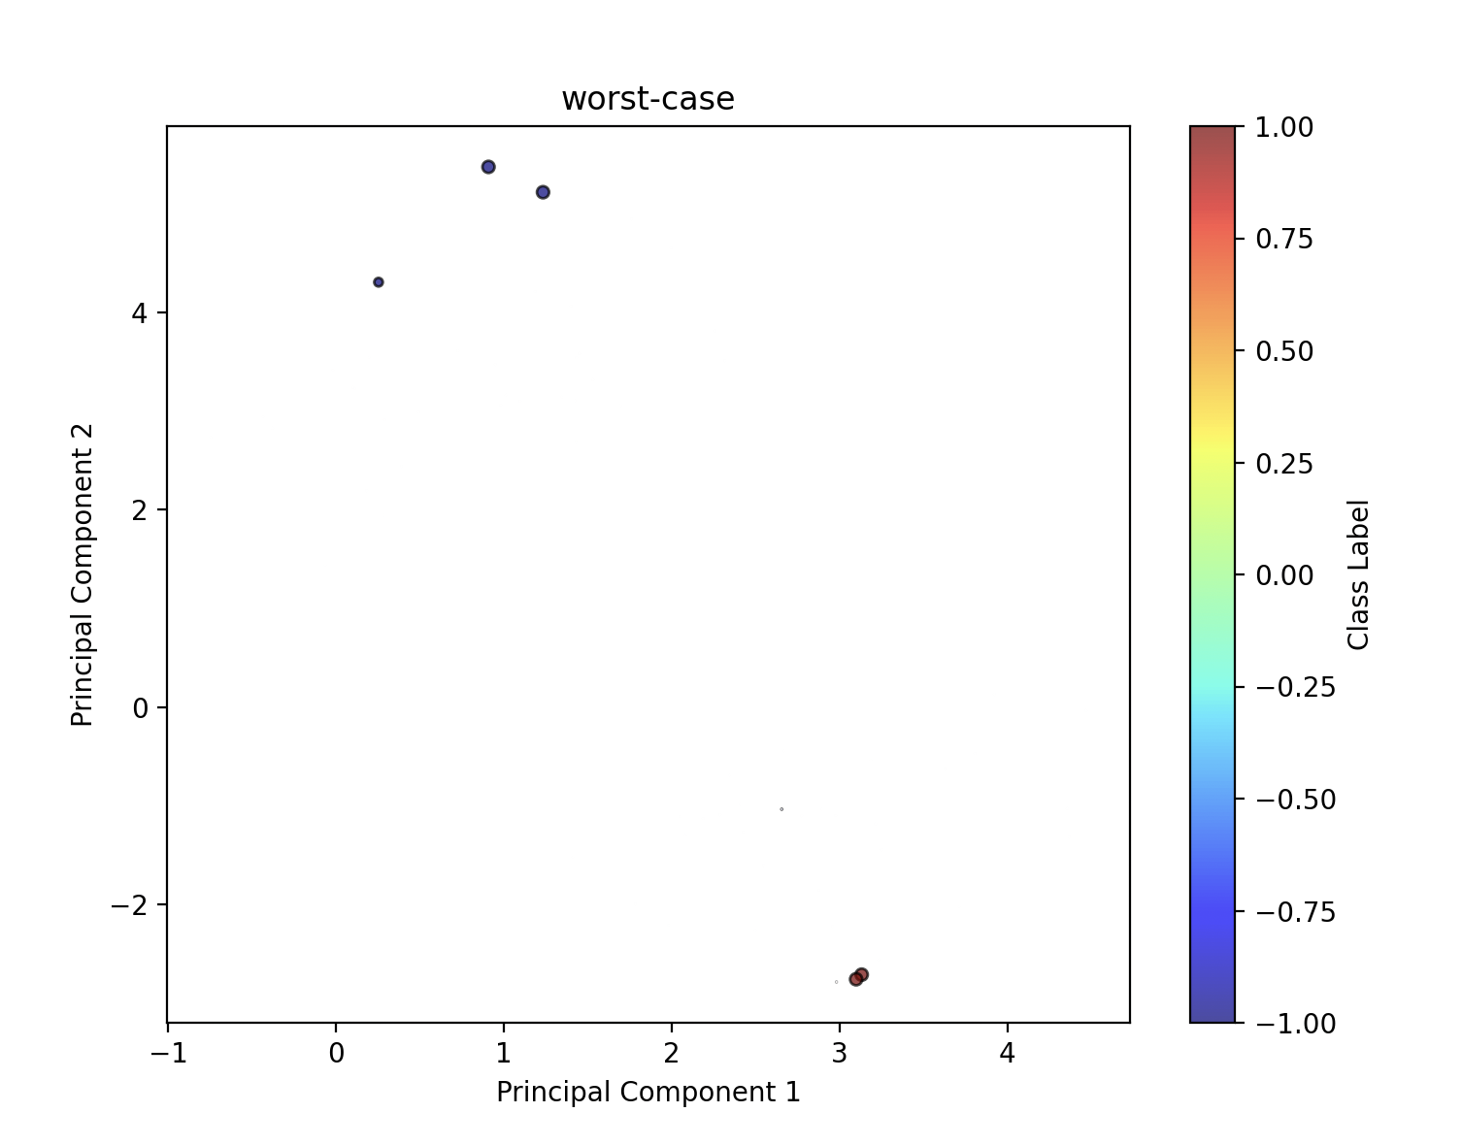

**回归任务**

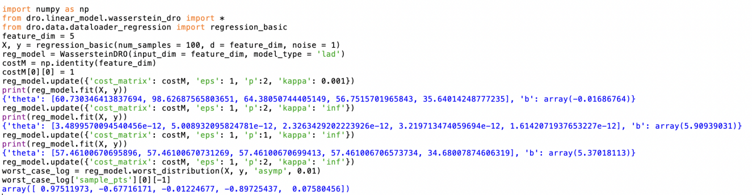

<https://chat.deepseek.com/a/chat/s/fb081a92-3708-48d1-9beb-6f0c6c35cc14>

**DRO with Mixed Distances**

**Sinkhorn DRO**

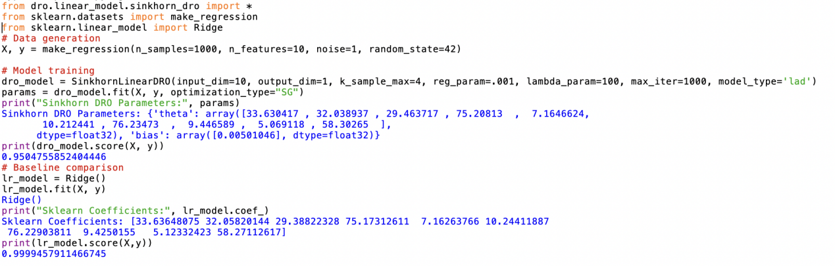

<https://chat.deepseek.com/a/chat/s/e611ef24-3ca8-41dd-b8fc-8a67d22e1a35>

**MOT-DRO**

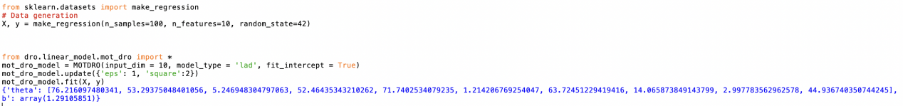

<https://chat.deepseek.com/a/chat/s/308d08d7-3d3f-4796-837c-7da197a55383>

**OR-WDRO + HR-DRO**

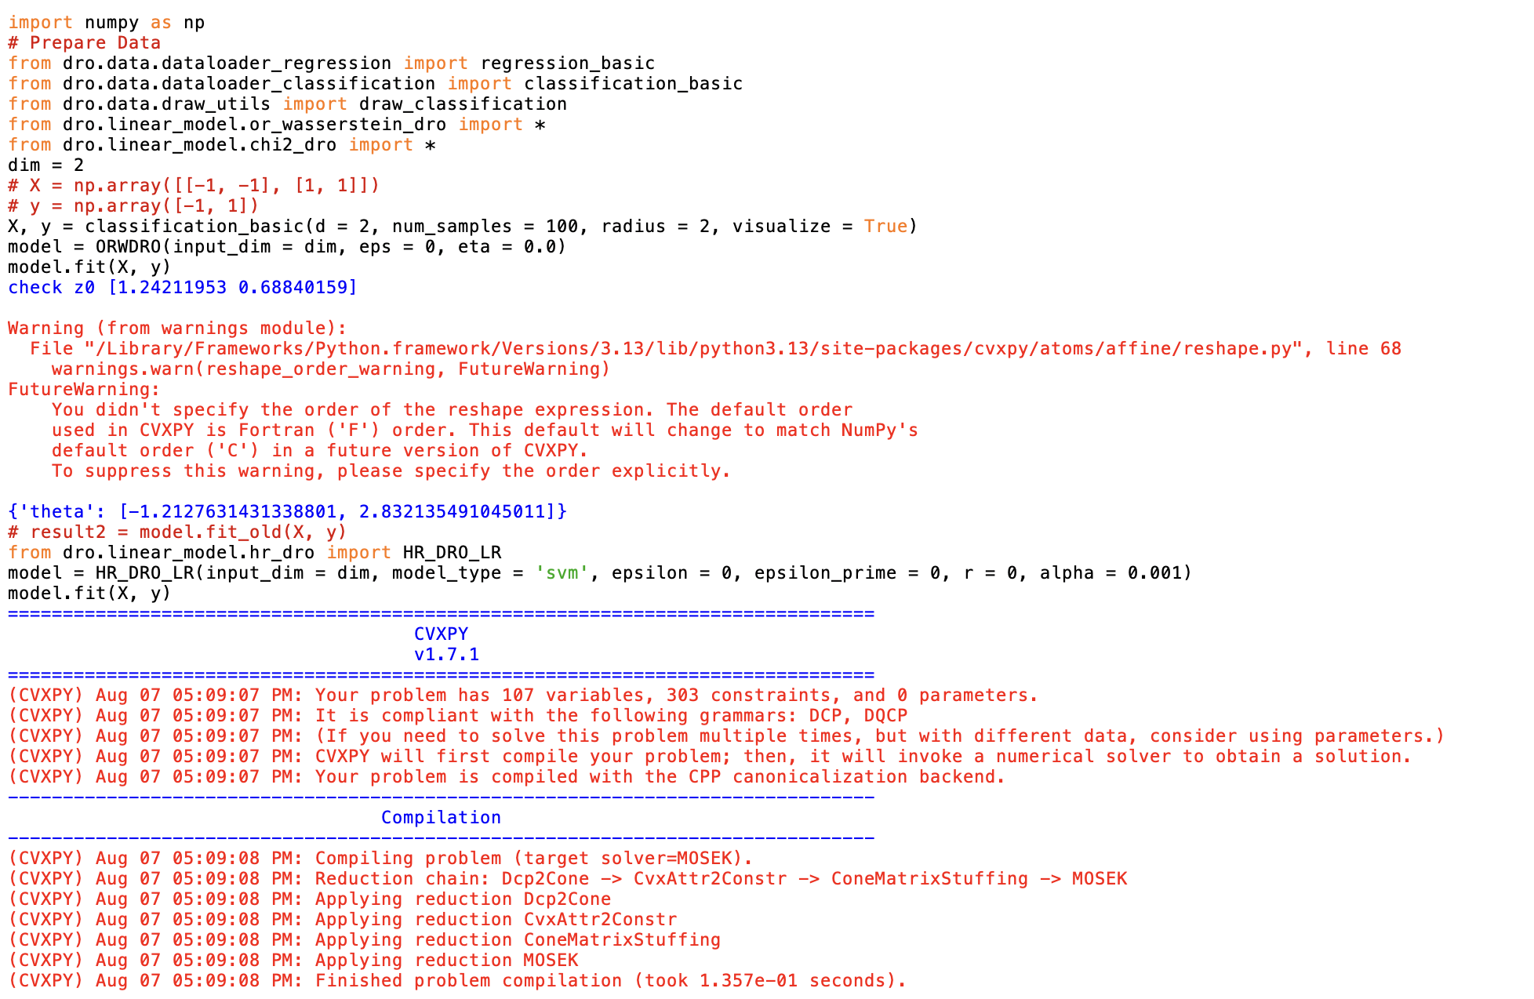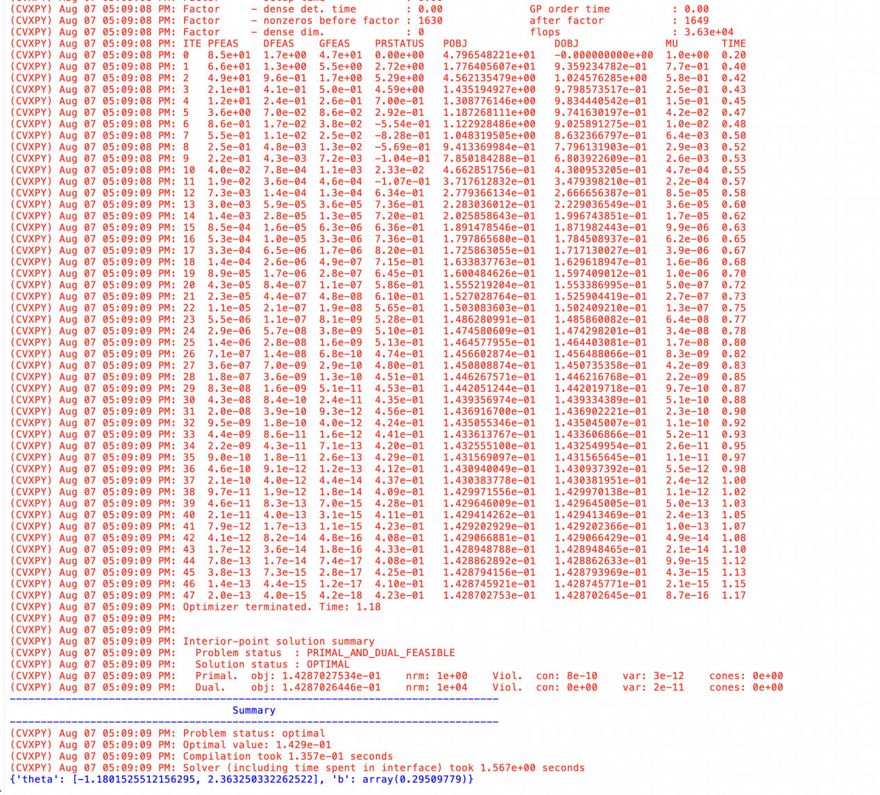

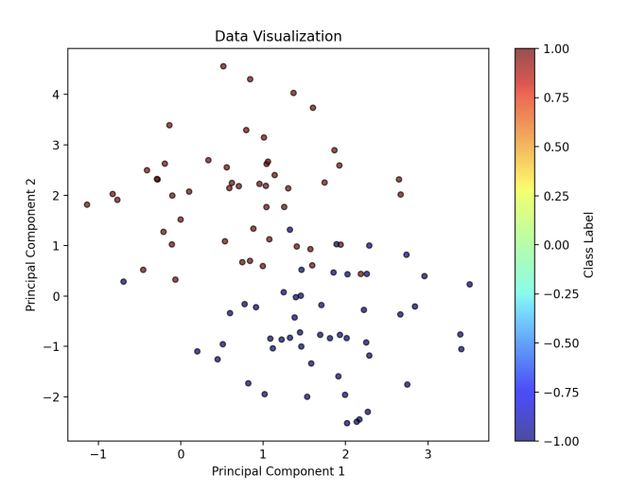

<https://chat.deepseek.com/a/chat/s/48383e89-71bd-4d92-ad89-297a0a75c43a>

**Bayesian DRO**

**Bayesian DRO解决 Newsvendor Problem（报童问题）**

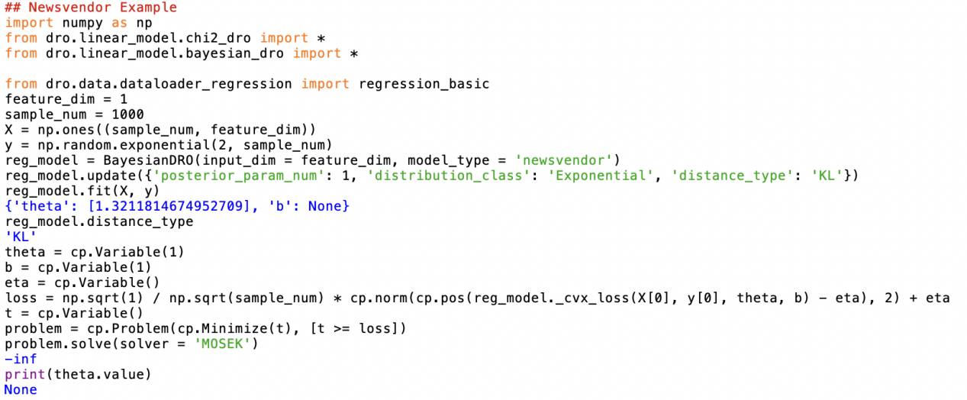

<https://chat.deepseek.com/a/chat/s/0aaa5fb1-b8bf-4335-b2da-ae4aab5109bb>

**Bayesian DRO进行回归分析**

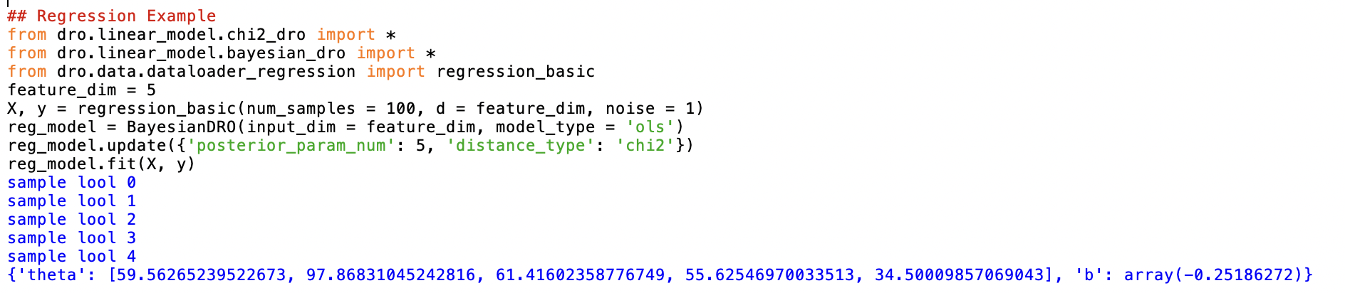

<https://chat.deepseek.com/a/chat/s/5348212f-04a0-4335-98e5-ae339be2a8f3>

**DRO on Tree-Ensemble Models**

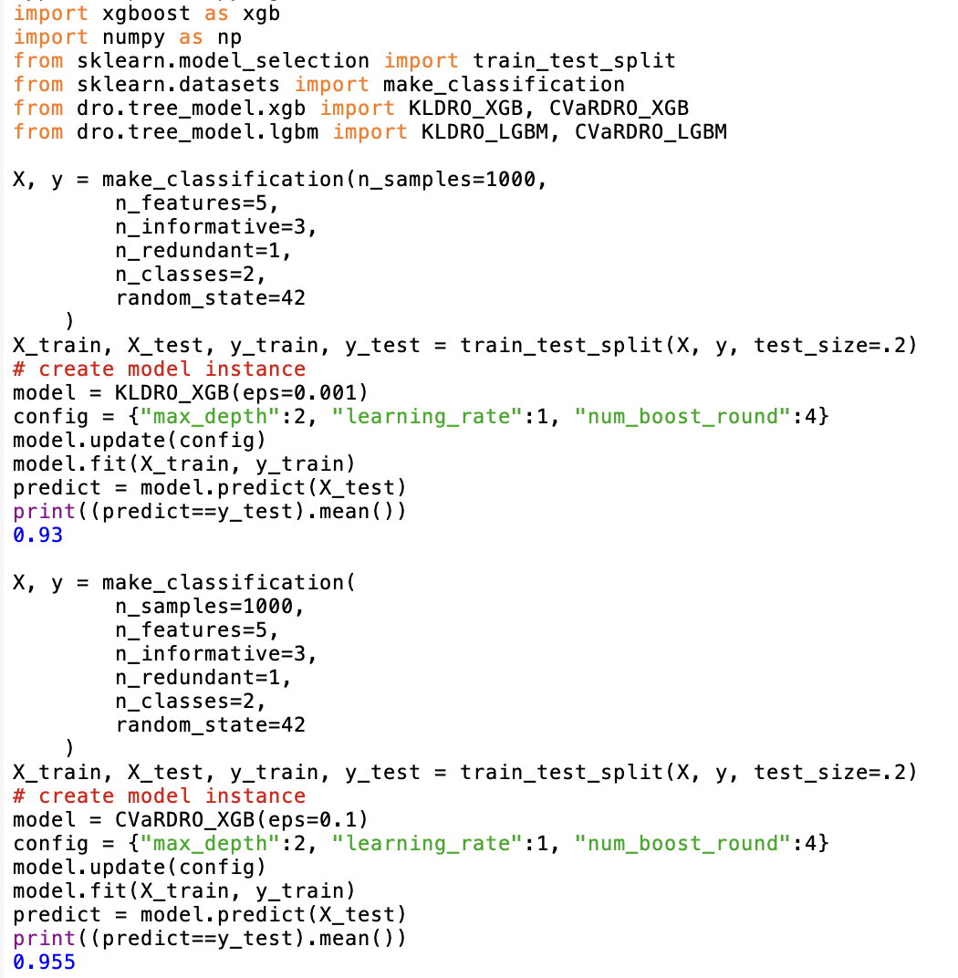

<https://chat.deepseek.com/a/chat/s/72096f50-af6f-4bd3-bc0b-914017ca0b89>

**Kernel Distributionally Robust Optimization**

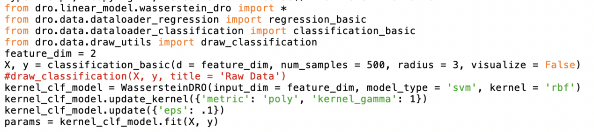

这段代码主要完成了以下工作：

* 导入必要的模块和函数
* 设置特征维度并生成分类数据
* 创建基于Wasserstein距离的分布鲁棒优化分类模型
* 配置模型参数（使用多项式核）
* 设置Wasserstein球的半径参数
* 训练模型并获取参数

如何使用不同类型的分布鲁棒优化(DRO)方法来构建分类模型：

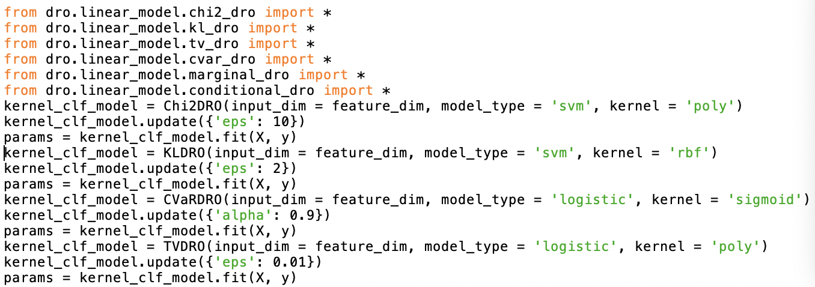

<https://chat.deepseek.com/a/chat/s/3c5e6b32-47a5-433e-8117-9ed08c45da7f>

在deepwiki网站中更详细的了解了dro包的核心架构、模型类型、DRO方法等。

其中遇到的问题询问deepseek一一解决<https://chat.deepseek.com/a/chat/s/cc4bfd17-7efd-4243-a598-2e06aaae261b>